Dickey-Fuller test conclusions

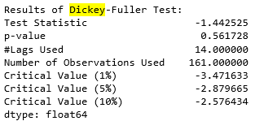

Dickey-Fuller test shows that null hypothesis (nonstationarity) cannot be rejected, so the time series may be nonstationary. If non-stationary, we cannot use AR(I)MA to fit the data, make inference or do forecasting. Thus, we need to make the time series stationary first.

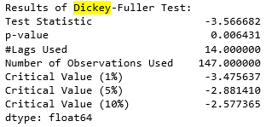

This time, we find that Dickey-Fuller test is significant (p-value<5%). This means, after removing general trend, the time series data probably become stationary.

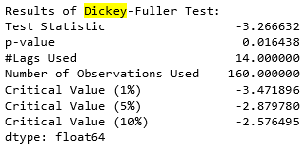

We see a remarkable improvement as the rolling mean and rolling standard deviation after differencing appear to be almost constant. The same was reflected by the Dickey-Fuller test as the test statistics come out to be much less than the 5% critical values. The de-seasonality and detrending can make time series seem to be almost stationary in nature now.

Note that after de-trending the time series, and you run Dickey-Fuller test, you may find that the transformed time series have already been stationary. This measn seasonality may not exert significant effect in this case. So you can just fit the AR(I)MA model on the stationary time series data. If it is still non-stationary, the possible reason is that seasonality has significant effect (e.g., seasonal random walk). Then you need to remove seasonality from the time series data.

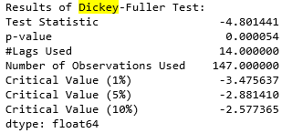

The residuals are stationary, but residuals may not seem like random noise (i.e., standard normal distribution). This is not a big issue. As long as the series become stationary now, you can fit the time series with time series model, such as ARMA or ARIMA. If you verify that variance may change within short-term periods, you can use models such as ARCH or GARCH to fit such residuals.[¶](http://localhost:8888/notebooks/Tutorials/Tutorial%206.%20Time%20Series%20Analysis/A0164651E_T6_program.ipynb#The-residuals-are-stationary,-but-residuals-may-not-seem-like-random-noise-(i.e.,-standard-normal-distribution).-This-is-not-a-big-issue.-As-long-as-the-series-become-stationary-now,-you-can-fit-the-time-series-with-time-series-model,-such-as-ARMA-or-ARIMA.-If-you-verify-that-variance-may-change-within-short-term-periods,-you-can-use-models-such-as-ARCH-or-GARCH-to-fit-such-residuals.)

If you want to know whether your stationary residual series have autocorrelation issue, you can visualize it using Autocorrelation Function (ACF), or check with statistical tests (In tutorial 5).